Load Memory Module (obsolete):
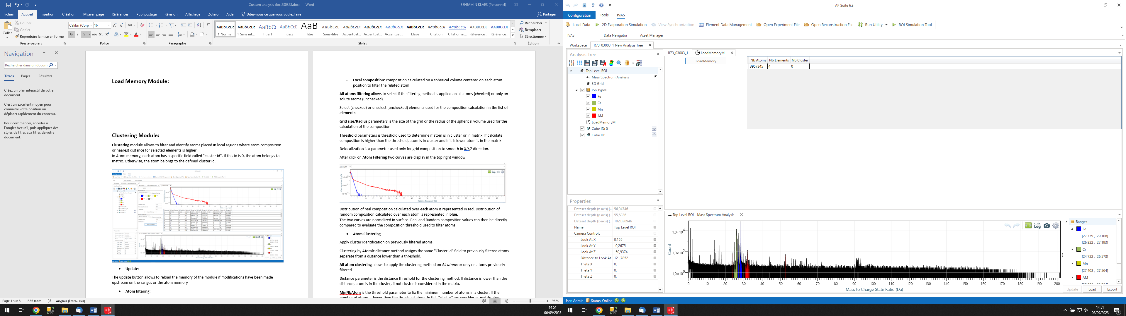
LoadMemory module must be used first before any other custom processing module. It allows loading the APSuite memory into a memory called CAtom that can be used by custom modules.
When the memory loading is complete, the number of atoms, the number of elements, and the number of clusters are displayed in the right-hand table.
Caution, the CAtom memory is singular. If it is reloaded after the use of other modules, anything saved in this memory during processing in the other modules will be overwritten.

Clustering Module:
Clustering module allows to filter and identify atoms placed in local regions where atom composition or nearest distance for selected elements is higher.
In Atom memory, each atom has a specific field called "cluster Id". If this Id is 0, the atom belongs to matrix. Otherwise, the atom belongs to the defined cluster Id.
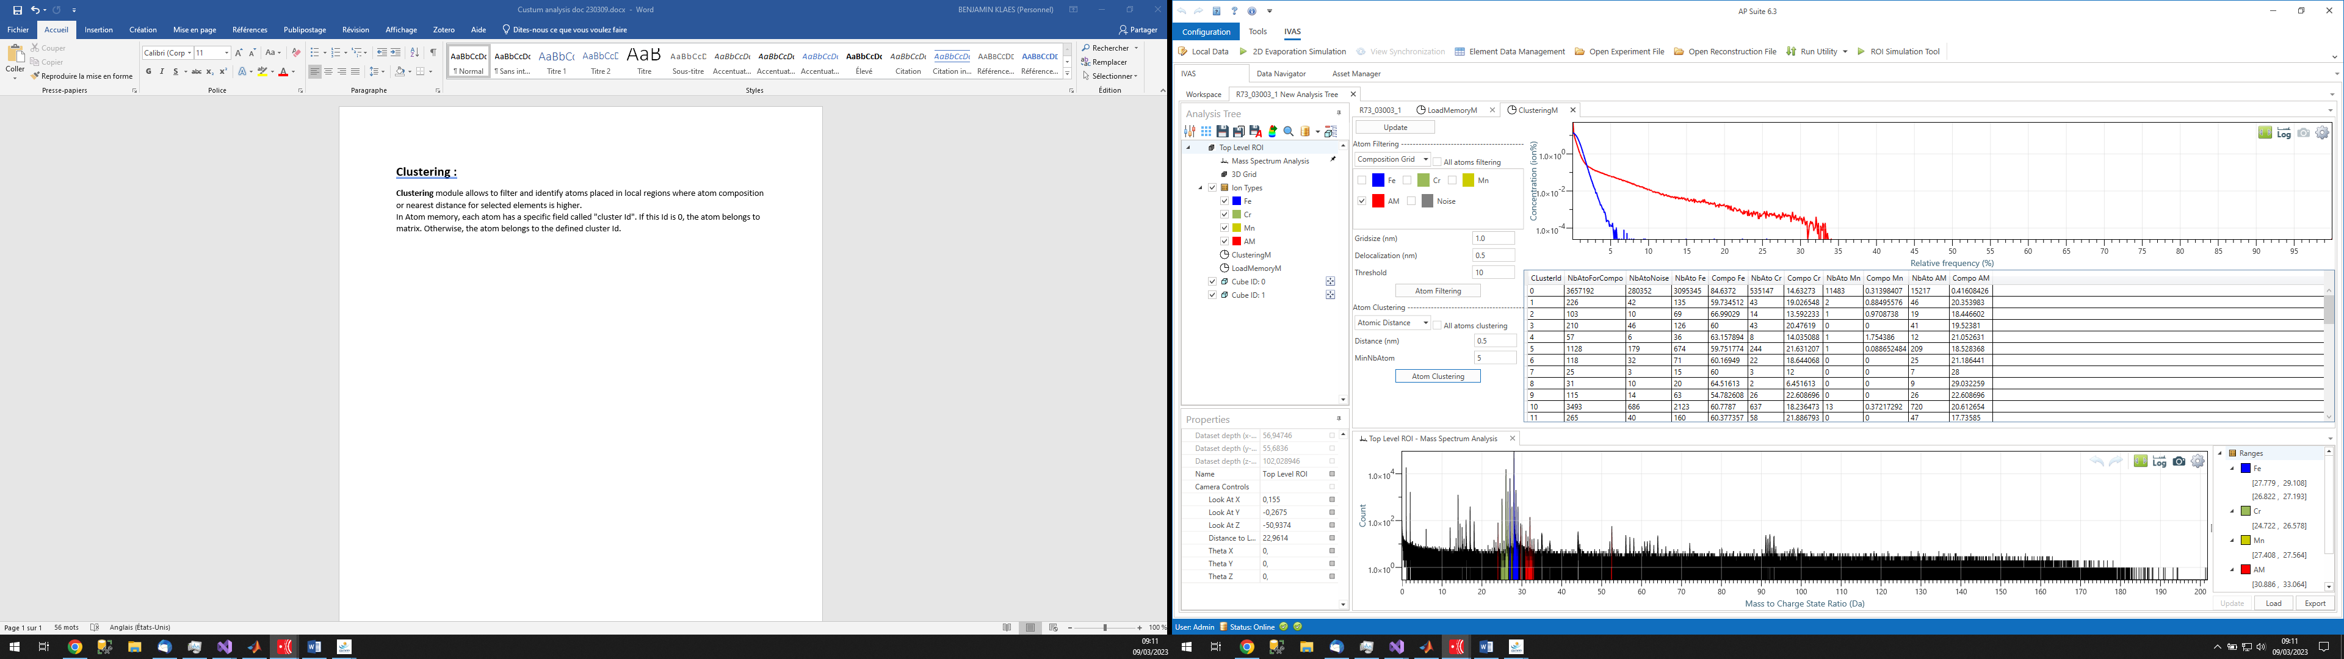
- Update Memory:
The update button allows to reload the memory of the module if modifications have been made upstream on the ranges or the atom memory
- Atom filtering:
Filter part of atoms placed in regions where atom density, composition or nearest distance for selected elements is higher. Filtering method is based on the composition with identification of 3d regions where atomic composition for selected elements is higher.
There are two filtering options:
- Grid composition: use a 3D grid composition calculate on the volume to filter atom
- Local composition: composition calculated on a spherical volume centered on each atom position to filter the related atom
All atoms filtering allows to select if the filtering method is applied on all atoms (checked) or only on solute atoms (unchecked).
Select (checked) or unselect (unchecked) elements used for the composition calculation in the list of elements.
Grid size/Radius parameters is the size of the grid or the radius of the spherical volume used for the calculation of the composition
Threshold parameters is threshold used to determine if atom is in cluster or in matrix. If calculate composition is higher than the threshold, atom is in cluster and if it is lower atom is in the matrix.
Delocalization is a parameter used only for grid composition to smooth in X,Y,Z direction.
After click on Atom Filtering two curves are display in the top right window.
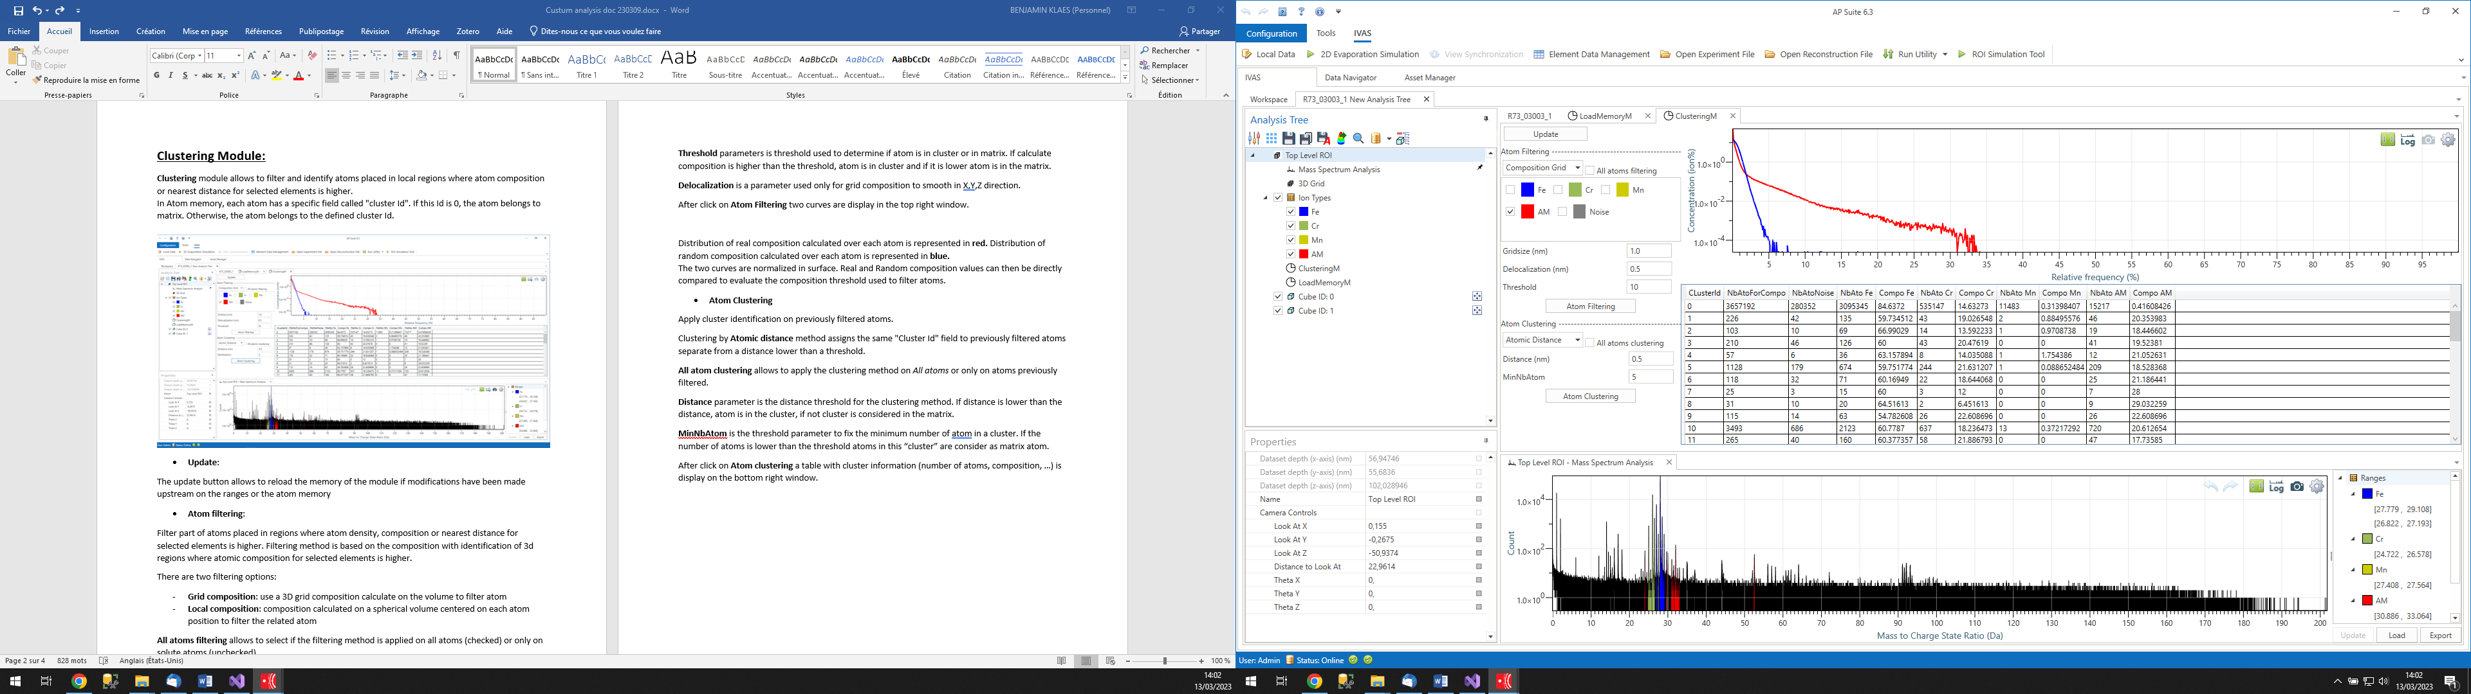
Distribution of real composition calculated over each atom is represented in red. Distribution of random composition calculated over each atom is represented in blue.
The two curves are normalized in surface. Real and Random composition values can then be directly compared to evaluate the composition threshold used to filter atoms.
- Atom Clustering
Apply cluster identification on previously filtered atoms.
Clustering by Atomic distance method assigns the same "Cluster Id" field to previously filtered atoms separate from a distance lower than a threshold.
All atom clustering allows to apply the clustering method on All atoms or only on atoms previously filtered.
Distance parameter is the distance threshold for the clustering method. If distance is lower than the distance, atom is in the cluster, if not cluster is considered in the matrix.
MinNbAtom is the threshold parameter to fix the minimum number of atoms in a cluster. If the number of atoms is lower than the threshold atoms in this “cluster” are consider as matrix atom.
After click on Atom clustering a table with cluster information (number of atoms, composition, …) is display on the bottom right window.


Cluster Position Module:
Cluster Position module allows to represent xyz position of the current Atom memory with a color-element, color-cluster Id or color-family Id.
In Atom memory, each atom has a specific field called "cluster Id". This field comes from the result of a Clustering Module (need to be calculate before)
If this Id is 0, the atom belongs to matrix. Otherwise, the atom belongs to the specify cluster Id.
Then atom representation can be filtered in function of the cluster Id, Element Id or Family Id.
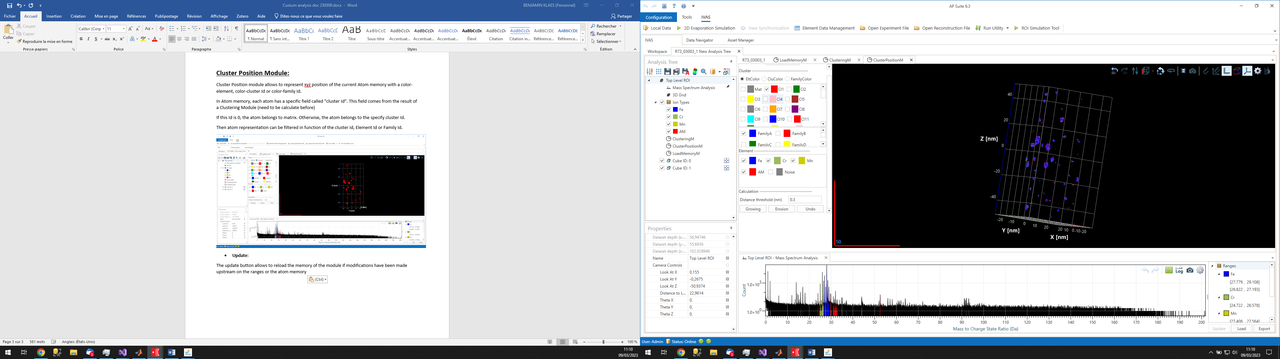
- Update Memory:
The update button allows to reload the memory of the module if modifications have been made upstream on the ranges or the atom memory
- Cluster
Select EltColor to represent clusters with the color of elements, CluColor to represents the clusters with the color of cluster Id or FamilyColor to represent the clusters with the color of the family Id.
In the list of clusters Select (Checked) or unselect (Unchecked) the cluster to represent only selected clusters. Right click on this list open a contextual menu with options to select all the clusters, deselect all the clusters or move selected cluster to another family (only selected (checked) cluster will be move).
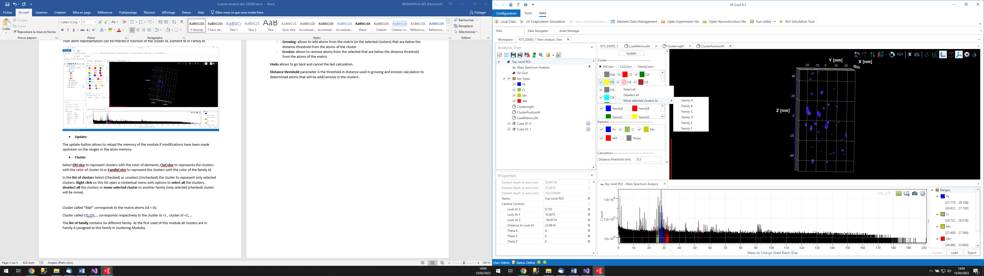
Cluster called “Mat” corresponds to the matrix atoms (Id = 0);
Cluster called Cl1,Cl2,… corresponds respectively to the cluster Id =1 , cluster Id =2, …
The list of family contains six different family. At the first used of this module all clusters are in Family A (assigned to this family in clustering Module).
- Element
The list of elements allows to select (checked) or unselect (unchecked) element that will be represented.
- Calculation
There are two calculation options:
- Growing: allows to add atoms from the matrix (in the selected clusters) that are below the distance threshold from the atoms of the cluster
- Erosion: allows to remove atoms from the selected that are below the distance threshold from the atoms of the matrix
Undo allows to go back and cancel the last calculation.
Distance threshold parameter is the threshold in distance used in growing and erosion calculation to determined atoms that will be add/remove in the clusters.
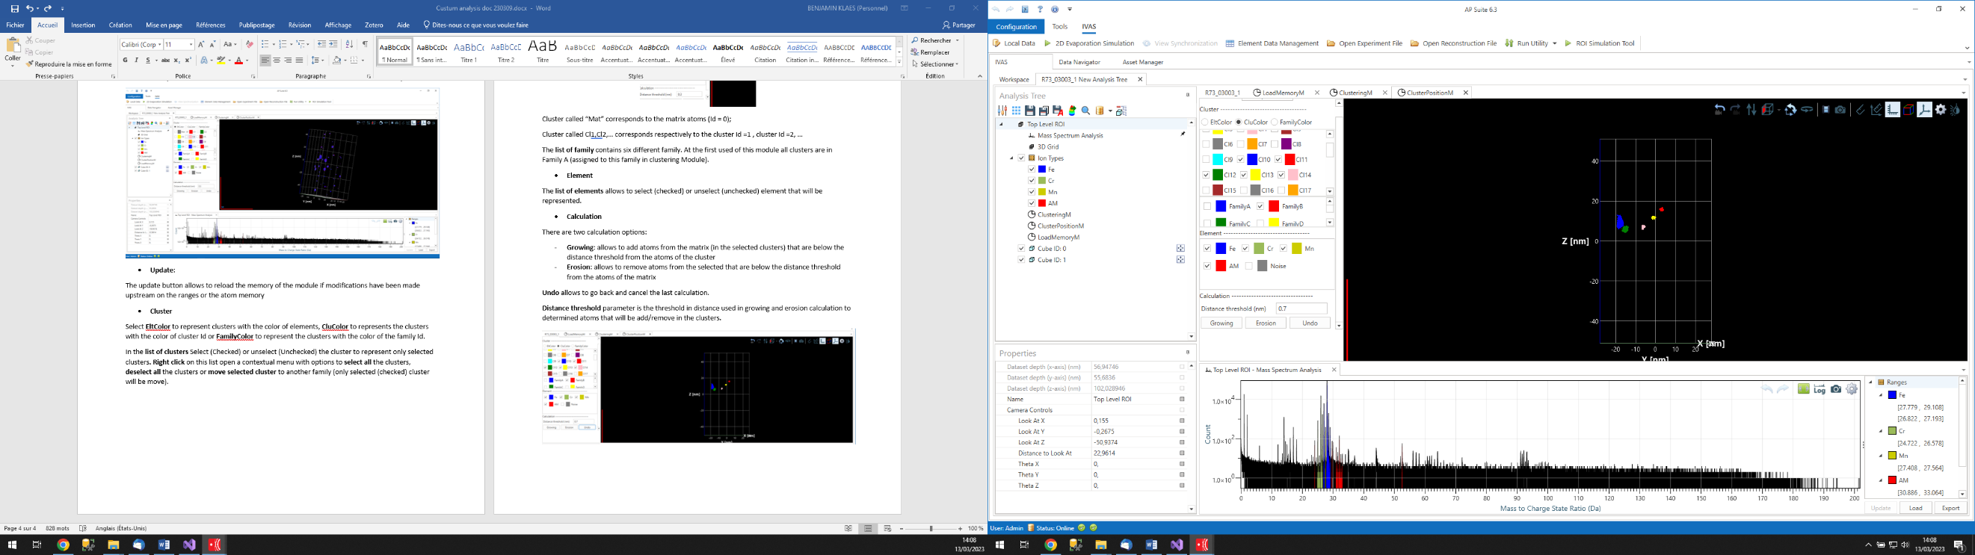
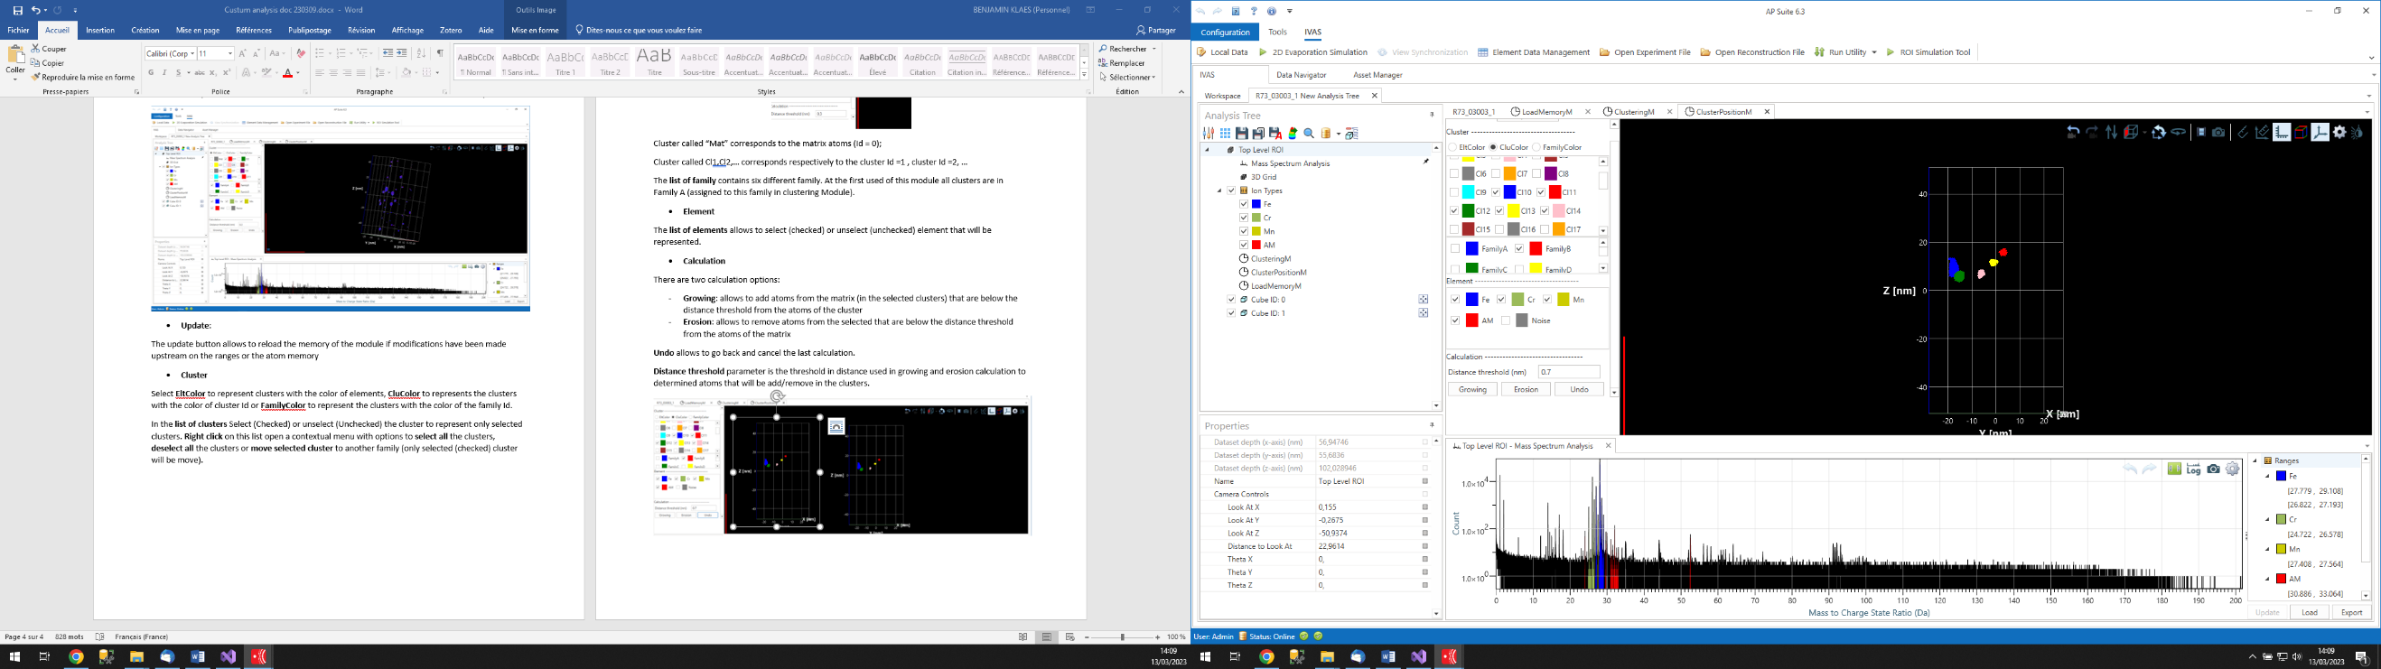
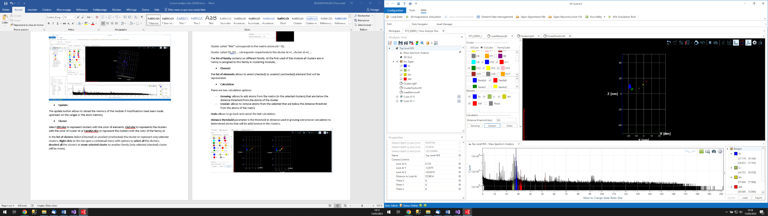
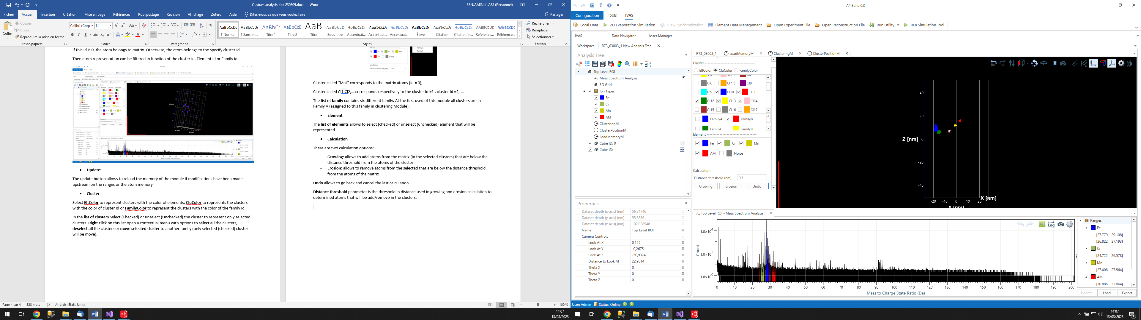
Erosion
Growing
Original
The example above shows the results for a growing and erosion calculation with a distance threshold parameter of 0.7nm. The calculation was made only on clusters in Family B.
- K-Means clustering
K-means clustering allows separating clusters that remained connected after using classical clustering methods.
First, select from the list of clusters those on which the algorithm should be applied.
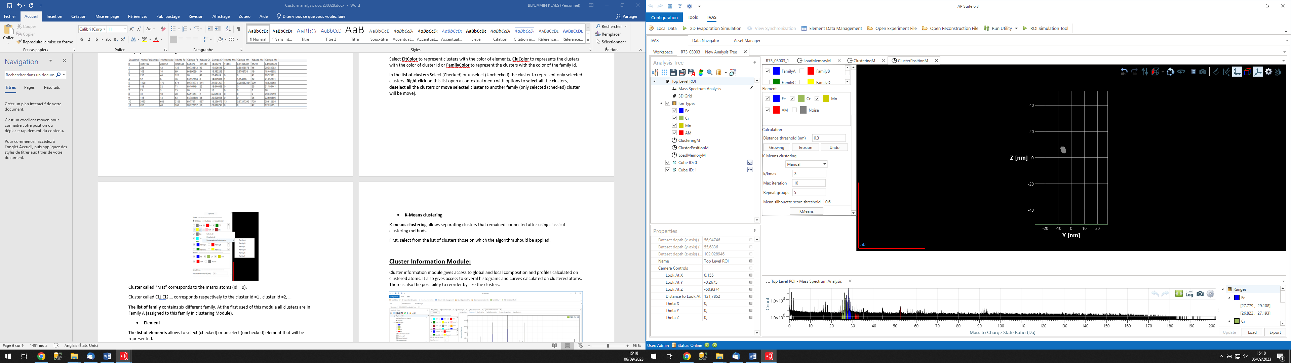
Two calculation options are possible: Manual or Auto. In Manual mode, you constrain the number of clusters present in the group to be separated by specifying this value in the k/kmax field.
In Auto mode, the algorithm will test all values for the number of clusters between 1 and the number indicated in the k/kmax field. The result for which the silhouette score is maximized will be selected by the algorithm to perform the separation of clusters in the selected group.
Max Iteration field is as a stopping criterion. Max Iteratio' is used to stop the calculation for a cluster group if the convergence of the calculation of the positions of each cluster's center within the group is not achieved before (a value less than 20 is recommended).
Repeat groups is the number of times the convergence calculation will be repeated for each cluster group to determine the optimal solution (a value between 3 and 6 is recommended).
The Mean Silhouette Score Threshold field allows filtering the cluster groups affected by the calculation. If, for a group, the score is below the specified threshold, then the cluster separation will not occur. This helps filter out, especially in automatic mode, cluster groups where separation is not possible or not reliable. This value depends on the shape and configuration of the cluster group, but generally, a calculation resulting in a mean silhouette score lower than 0.55 can be excluded.

Cluster Information Module:
Cluster information module gives access to global and local composition and profiles calculated on clustered atoms. It also gives access to several histograms and curves calculated on clustered atoms. There is also the possibility to reorder by size the clusters.
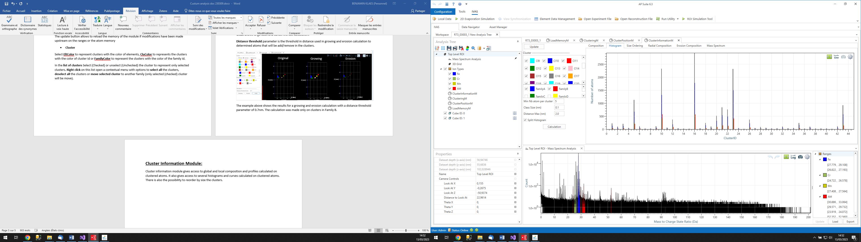

The calculation is made on the selected tab :

- Update Memory:
The update button allows to reload the memory of the module if modifications have been made upstream on the ranges or the atom memory
- Composition
Composition tab shows a table with the composition of each selected cluster.
For each selected cluster and from atoms in memory, this application calculates the number of atoms, the composition and the relative error associated to elements defined in the Environment file.
The equivalent Guinier - Giration radius, the average position an are also available.
Note that composition weight parameter, defined for each mass range, is used to calculate composition value.
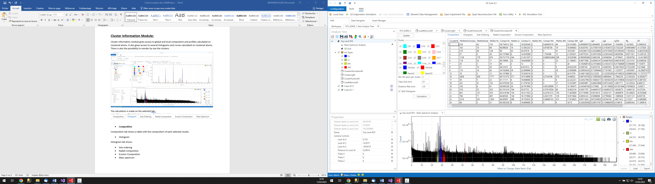
- Histogram
Histogram tab shows a histogram of the composition per selected clusters. For each selected cluster and from atoms in memory the number of atoms in mass is plot on the histogram.
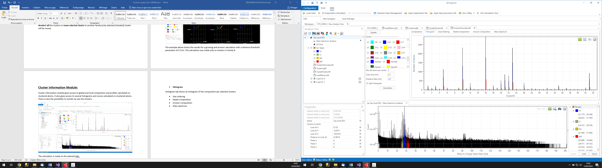
- Size ordering
The size ordering tab will reorder the clusters from the one with the fewest atoms to the one with the most.
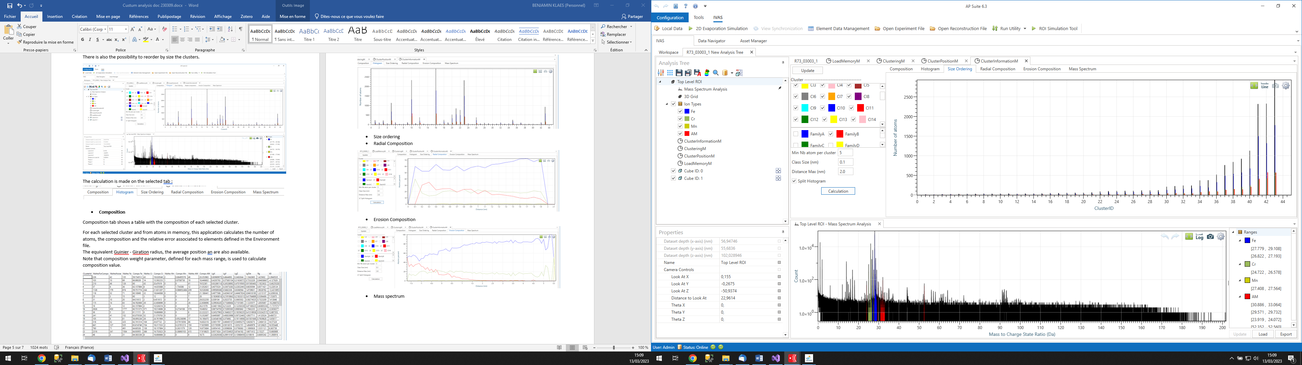
- Radial Composition
For each selected cluster and from atoms available in memory, this application places a spherical volume to the average of the related atom positions.
The radius of this volume increases step by step until a maximum value, that allows to calculate and show the variation of element composition inside each step.
If more than one cluster is selected, the profile is the result of the sum of variations calculated over each individual cluster.
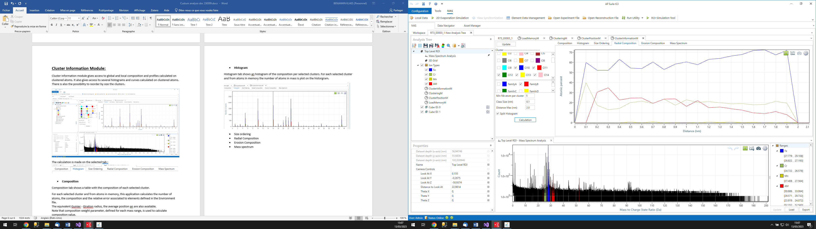
Class size parameter defines the increment value of the sphere radius.
Distance Max parameter defines the maximum radius variation used to build the profile.
- Erosion Composition
For each selected cluster and from atoms available in memory, this application places a 3d shape volume corresponding to the cluster - matrix interface.
The distance from both side of this interface shape increases step by step, that allows to calculate and shows the variation of element composition inside each step from matrix to cluster and from cluster to matrix interfaces.
If more than one cluster is selected, the profile is the result of the sum of variations calculated over each individual cluster.
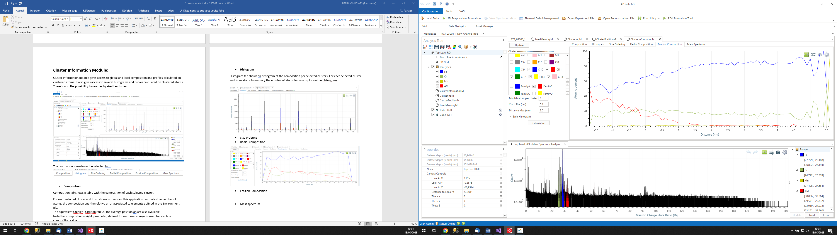
Class size parameter defines the increment value of the distances between atoms and the 3d shape volume corresponding to the cluster - matrix interface.
Distance Max parameter defines the maximum distance used for atoms from matrix that surround the 3d shape volume corresponding to the cluster - matrix interface.
- Mass spectrum
The mass spectrum tab shows the histogram for each selected cluster. If split histogram is checked, one mass spectrum will display for each selected cluster with the color of the corresponding cluster. If split histogram is unchecked, only one mass spectrum will be display. This mass spectrum is the sum of all the mass spectrum of each selected clusters.
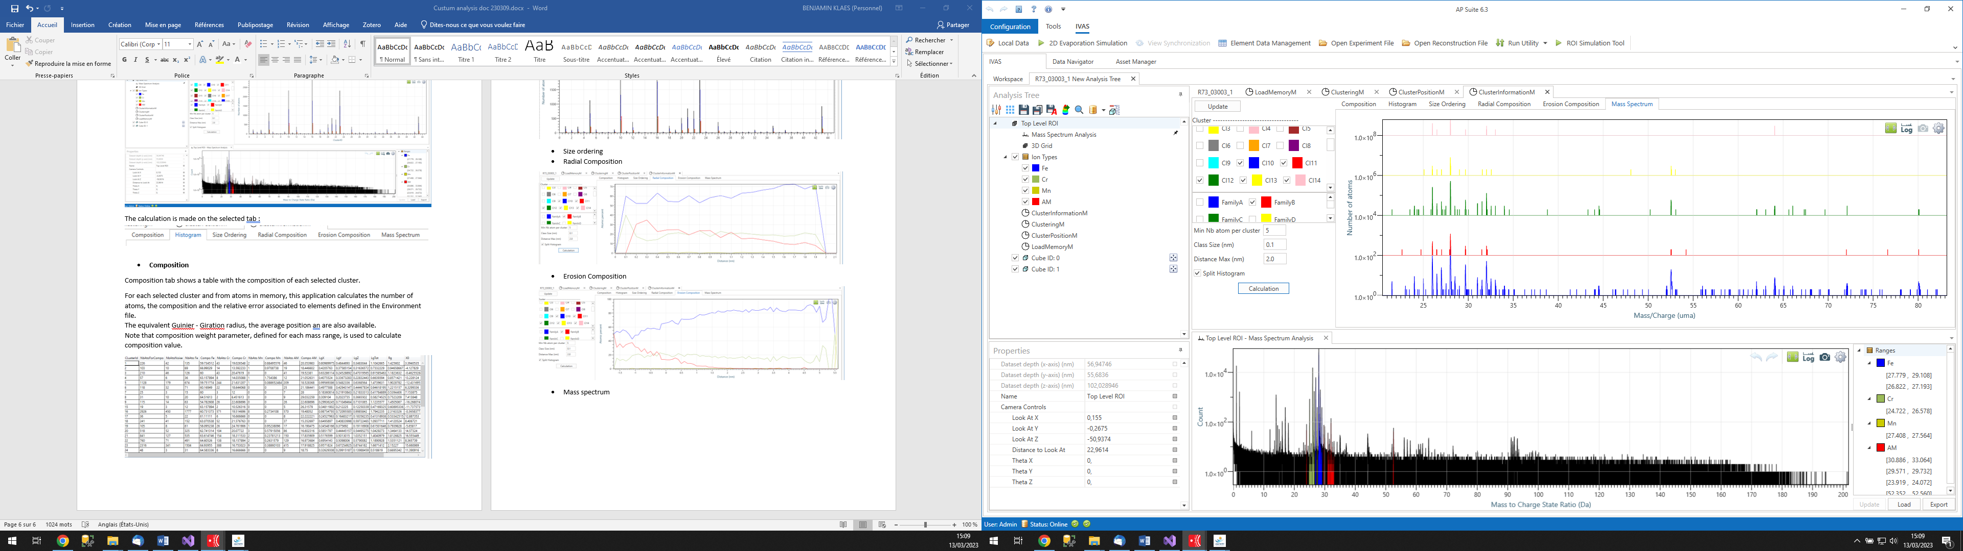

Gibbs Module:
Gibbs module gives access to the plotting of integral profiles and the calculation of the Gibbs excess.

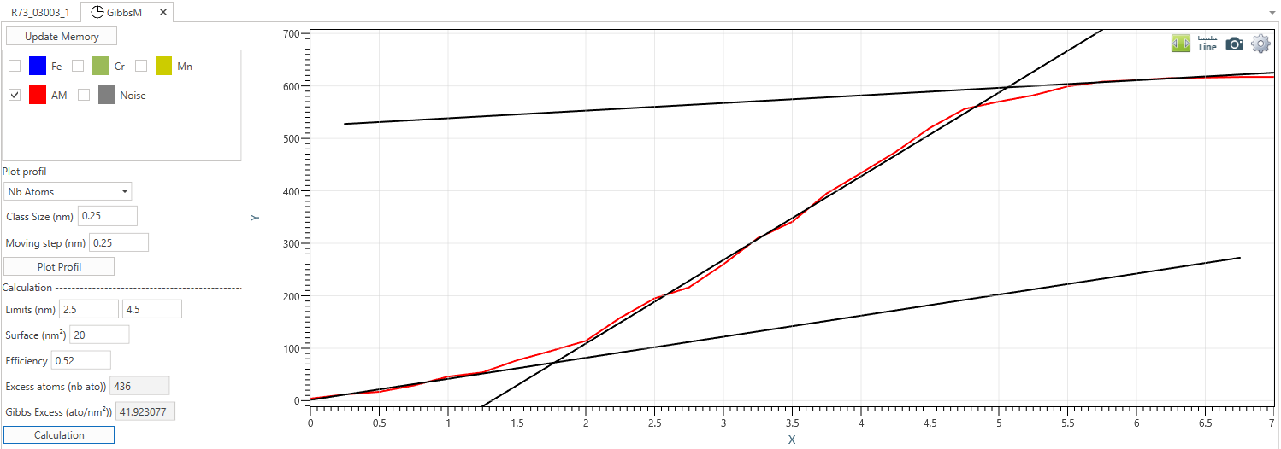
- Update Memory:
The update button allows to reload the memory of the module if modifications have been made upstream on the ranges or the atom memory
- Elements selection
The element selection window allows you to choose on which element the integral profiles will be traced. Warning: to then calculate the Gibbs excess the composition profile of a single element must be traced at times.
- Plot profile
The profile plot section allows you to trace the integral profile along the Z axis (depth): two possibilities of choice either in number of atoms or in percentage.
  - Class size: allows to define the thickness (in nm) of the selection box on which the local composition is calculated
  - Moving step: allows to define the distance by which the selection is moved along Z each time the local composition is calculated to create the profile.

- Calculation
Warning: you need to plot profile before
The calculation section allows to calculate the Gibbs excess automatically thanks to a fit of three lines on the three linear portions of the integral profile by linear regression and minimization of the error. Several parameters are necessary:
  - Limits: Limits correspond to the limits on the X axis of the integral profile (nm) of the linear part at the center (the limits do not need to be precise, they just serve as reference points for the algorithm. For example, on the profile above between 2.5nm and 4.5 nm the evolution of the integral profile is linear)
  - Surface: is the area in nm² of the selection
  - Efficiency: is the detection efficiency of the instrument on this analysis
The number of excess atoms and the excess of Gibbs that was calculate by the algorithm (atom/nm²) are given respectively in Excess atoms and Gibbs Excess

Fourier Module:
The Fourier module allows computing the Fourier transform in 1D or 3D on a selected volume. It also enables the determination of spatial resolution from the Fourier transform. Note: The larger the number of atoms in the selection, the longer the computation time. Typically, a few hundred atoms are sufficient to compute the Fourier transform.
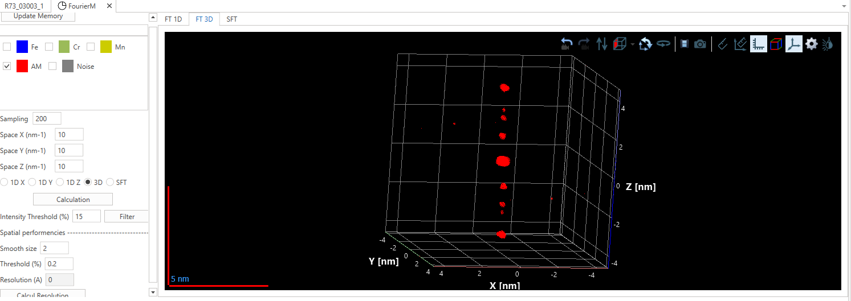
- Update Memory:
The update button allows to reload the memory of the module if modifications have been made upstream on the ranges or the atom memory
- Elements selection
The element selection window allows you to choose on which element the Fourier transform will be traced. You can select one or more elements different of noise.
- Parameters
  - Sampling: Allows specifying the number of points in Fourier space for each dimension. If the sampling is set to 100, the three dimensions X, Y, and Z of Fourier space will be subdivided into 100 calculation points. In 3D, the space will be divided into ${100}^{3}$ voxels.
  - Space X: Is the size in nm-1 on the X-axis.
  - Space Y: Is the size in nm-1 on the Y-axis.
  - Space Z: Is the size in nm-1 on the Z-axis.
  - Type of Fourier calculation: Allows selecting between computing the Fourier transform in 1D along one of the axes (1DX, 1DY, 1DZ) or the 3D Fourier transform. The results will be displayed in the FT1D and FT3D tabs on the right, respectively.
- Intensity threshold: Allows selecting the intensity threshold for displaying the 3D Fourier transform result. If the Fourier transform intensity of a point in Fourier space is below the threshold, it will not be displayed.
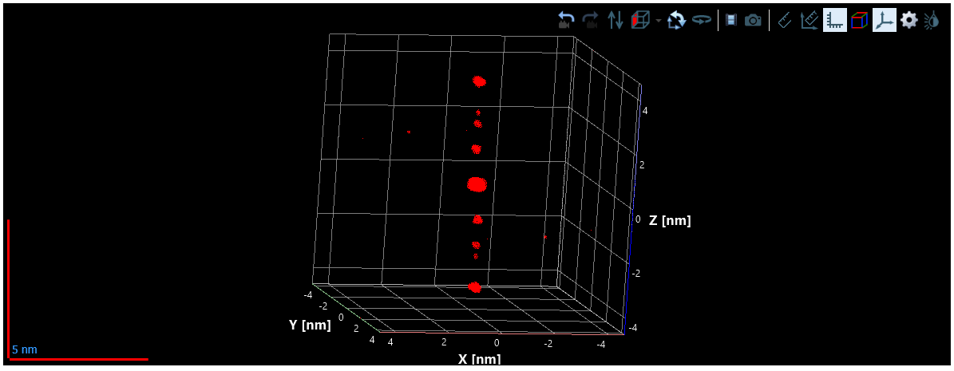
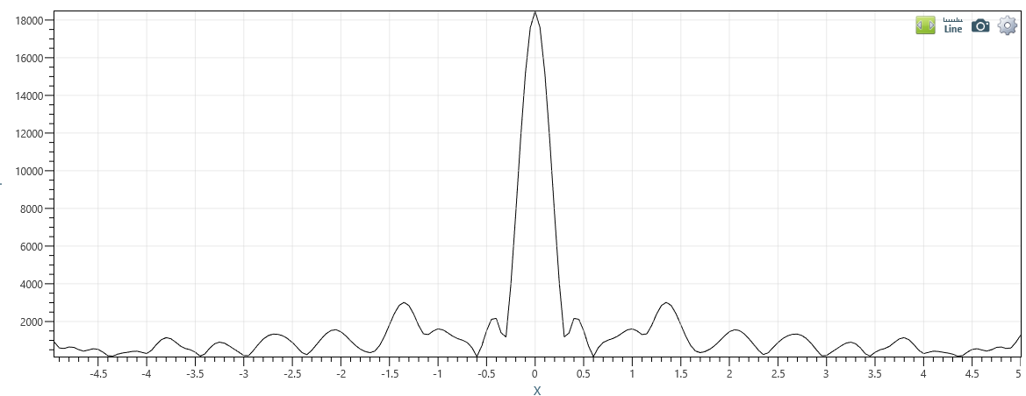
- Spatial performances:
  - Rotation angles: Allows defining the X and Y angles to position atomic planes orthogonal to the Z-axis. For computational efficiency, the Fourier transform is only calculated along the Z-axis, not in 3D, to determine spatial resolution. Therefore, the planes must be positioned as orthogonally as possible to the Z-axis.
Note: The algorithm includes a correction for the X and Y angles to find the maximum intensity, but this correction is limited to ±5° for speed reasons. A preliminary rotation is therefore required to position the planes as close as possible to an orthogonal position relative to the Z-axis by setting the rotation angles in these parameters before starting the calculation.
  - Smooth size: Defines the window size (integer value) used to smooth the curve and reduce the impact of noise for peak detection. The calculation is performed using a moving average over the window size specified in this parameter.
  - Threshold: These parameters corresponds to the normalized threshold value (0 - 1) below which peaks will no longer be detected.

